**Acknowledgement**

We are happy to submit our idea of “SOCIETY HUB” in Gujarat Technology University, Ahmadabad for Bachelor Engineering degree in computer branch.

The institute Atmiya Institute Technology and Science, which is due to the Param Pujya Hariprasad Swamiji and his blessings. We are so thankful to them that he has given us such a supportive institute and its environment .He is so supportive and spiritual and continuously inspiring to give our best.

We are highly obliged to Param Pujya Tyagvallabh Swamiji to give us continuous motivated environment and such a nice management.

This dissertation has been prepared under the most supporting guide Prof. Nirali C. Varnagar of Department of Computer Engineering, Atmiya Institute of Technology and Science, Rajkot.

Due to her continuous support, guidelines, her helping nature, and very thankful to her to any time resolving our queries and provides all necessary facilities during our work. Also thankful for giving us such new directions. Without her keen interest and knowledge of the subject and constant encouragement we cannot complete our dream.

We are also grateful to Prof. T.M.Kodinariya Head of the Department and all the faculty members of the Department of Computer Engineering for their kind support throughout this journey.

We also take the privilege to acknowledge the elite authors of numerous books and papers and blogs which we have referred during progress of this.

We also really thankful to Mr.Niraj Kumar, our external guide to support at each phase of this.

Without his guidelines we cannot complete our work at proper time.

We also say the big thank you to our parents for such a support and without them we can do nothing not in just project but also in life. Thankful to our family for their support.

The feeling of gratefulness to any one’s help directly arises from the bottom of heart. A small but an important and timely help can prove to be a milestone in one’s life.

We take the opportunity to thank all those who have directly or indirectly helped us to fulfil our dream.

Very thankful to almighty of all of us ”God” to give us such a best persons and all the thing he provides before we need and we always feel that without him we are nothing.

Vaghasiya Nidhi M.

Divraniya Lakhan B.

**ABSTRACT**

The use of Internet has been substantially increasing for last decade and today everything is going to be online. People face difficulties in Manage Society at manually. Since this project is designed to provide the user to be able to manage and maintain their society at online, this will avoid wastage of time.

As this is the century of CREATIVITY, it is not only possible by one hand but it requires many hands. So, for development of our country and human beings, this portal gives its small contribution.

This is an easy to use and easy to implement type of system. This project stores the data of society. This web application is free of dummy data and it is also a free of cost facility provided to society. It has excellent features like the Accounting Module, Asset Management and User Management etc. which automates all administrative overheads of the society and enables the management to focus on more important tasks. The web interface is easy to use and it has well defined roles of Admin, Manager, Members and Tenants. Exhaustive reports cover most of the reporting and communication.

In this project there are 5 modules

1. Admin
2. Billing
3. Event
4. User
5. Resource

**ATMIYA**

**INSTITUTE OF TECHNOLOGY & SCIENCE**

**RAJKOT**



This is to certify that the project entitled “**SOCIETY HUB**” is a bonafied report of the work carried out by **Ms. Vaghasiya Nidhi M.** under the guidance and supervision for the work of Project-I at Atmiya Institute of Technology and Science - Rajkot, Gujarat.

To the best of my knowledge and belief, this work embodies the work of candidate herself, has duly been completed, fulfills the requirement of the ordinance relating to the Bachelor degree of the university and is up to the standard in respect of content, presentation and language for being referred to the examiner.

**SIGNATURE SIGNATURE**

PROF.TRUPTI KODINARIYA MRS NIRALI VARNAGAR

**HEAD OF THE DEPARTMENT ASST PROF**

C. E. DEPARTMENT C. E. DEPARTMENT

**ATMIYA**

**INSTITUTE OF TECHNOLOGY & SCIENCE**

**RAJKOT**



This is to certify that the project entitled “**SOCIETY HUB**” is a bonafied report of the work carried out by **Mr. Divraniya Lakhan B.** under the guidance and supervision for the work of Project-I at Atmiya Institute of Technology and Science - Rajkot, Gujarat.

To the best of my knowledge and belief, this work embodies the work of candidate herself, has duly been completed, fulfills the requirement of the ordinance relating to the Bachelor degree of the university and is up to the standard in respect of content, presentation and language for being referred to the examiner.

**SIGNATURE SIGNATURE**

PROF.TRUPTI KODINARIYA MRS NIRALI VARNAGAR

**HEAD OF THE DEPARTMENT ASST PROF**

C. E. DEPARTMENT C. E. DEPARTMENT

**LIST OF TABLES**

|  |  |  |
| --- | --- | --- |
| Table No | Table Description | Page No. |
| 1 | HARDWARE | 14 |
| 2 | SOFTWARE | 14 |
| 3 | PROJECT PLANNING | 18 |
| 4 | WORK SCHEDULE | 19 |
| 5 | Tbl_Admin | 29 |
| 6 | Tbl_Member | 29 |
| 7 | Tbl_User | 29 |
| 8 | Tbl_Event | 30 |
| 9 | Tbl_Billing | 30 |
| 10 | Tbl_Staff | 30 |
| 11 | Tbl_Resource | 30 |
| 12 | Tbl_Ratting | 31 |
| 13 | Main Modules | 44 |

**LIST OF FIGURES**

|  |  |  |
| --- | --- | --- |
| Figure No | Figure Description | Page No |
| 1 | WATERFALL MODEL | 16 |
| 2 | Admin Module | 33 |
| 3 | Staff Module | 34 |
| 4 | User Module | 35 |
| 5 | Visitor Module | 36 |
| 6 | DATA FLOW DIAGRAM (Level 0) | 38 |
| 7 | FIRST LEVEL DFD: Admin | 39 |
| 8 | FIRST LEVEL DFD: Staff | 40 |
| 9 | FIRST LEVEL DFD: User | 41 |
| 10 | FIRST LEVEL DFD: Visitor | 42 |
| 11 | Class Diagram | 43 |

**CHAPTER-1 INTRODUCTION**

# **1.1-PURPOSE**

It helps us clearly track our assets, liabilities, incomes, expenses and helps in providing complete transparency.

Opinion of Society Hub are helping apartment managements to convert from paper based management to e-management. With tools like Income, Expense, Security, Bank, Parking, Society Helpdesk, etc. are available.

With Society Hub Residents come onto a common online platform, enabling seamless communication and participation in Society related Decision Making. Complaint lodging and tracking becomes transparent. Residents can form Groups, Share Photos and much more.

* Most comprehensive Society Management software - a One-stop Portal for Owners, Tenants & Management Office.
* Brings Professionalism and Transparency to running of the Association.
* Brings continuity and stability in the processes / systems, irrespective of the changes in Association Office.
* All you need is a PC & a Browser, Association does not have to bother about Software or Hosting Infrastructure.
* Each Association is interconnected with other Associations on the Society Hub Network - contributing and utilizing Best Practices.

# **1.2-SCOPE**

Scope of this project is very wide, from small person to society and everyone who want to do and know something new.

Before this Hub platform people needs to manage their accounting, housing cost and other things manually.

Apartment maintenance, management of facilities and taking care of residents issues taking away too much of your time and energy

Key features of Society Hub

* Maintenance
* Billing
* Resource
* Admin
* Complain/ Suggestion
* Event

# **1.3-OBJECTIVES**

**"A product that makes a thankless job of managing home owners associations fun and easy"**

Society Hub is a private portal for owners and residents of an apartment/villa complex for networking, society management and accounting. It is a model of manage users regular house requirements.

By developing such web application main aim is to society members who doesn’t have their own application or platform they can easily full fill their regular requirements.

Maintain details of all facilities in the Apartment Complex, related documents, service history, and maintenance dates and complaints records in one central module. Save lakhs in repair and breakdown costs, increase longevity of assets and add value to your property. Ensure continuity, i.e. on changing management committees, new members would have a seamless transition. Maintain data of staff and visitors in directories, track entry/exit details, generate reports on intelligence gathered.

* Ensure your Apartment Upkeep and Safety
* Stay connected with your Society / Association
* Be in the know of your Neighbourhood News, Events and Services

# **1.4-Technology and Tools**

***Front End:*** For designing the structure of the project following technologies are used:

1. **HTML:**

Hypertext Mark-up Language (HTML) is the main mark-up language for creating web pages and other information that can be displayed in a web browser.

HTML is written in the form of HTML elements consisting of *tags* enclosed in angle brackets

(Like <html>), within the web page content. HTML tags most commonly come in pairs like <h1> and </h1>, although some tags represent empty

Elements and so are unpaired, for example <img>. The first tag in a pair is the start tag, and the second tag is the end tag (they are also called opening tags and closing tags). In between these tags web designers can add text, further tags, comments and other types of text-based content.

The purpose of a web browser is to read HTML documents and compose them into visible or audible web pages. The browser does not display the HTML tags, but uses the tags to interpret the content of the page.

HTML elements form the building blocks of all websites. HTML allows images and objects to be embedded and can be used to create interactive forms. It provides a means to create structured documents by denoting structural semantics for text such as headings, paragraphs, lists, links, quotes and other items. It can embed scripts written in languages such as JavaScript which affect the behaviour of HTML web pages.

1. **CSS:**

Cascading Style Sheets (CSS) is a style sheet language used for describing the presentation semantics (the look and formatting) of a document written in a mark-up language. It’s most common application is to style web pages written in HTML and XHTML, but the language can also be applied to any kind of XML document, including plain XML, SVG and XUL.

CSS is designed primarily to enable the separation of document content (written in HTML or a similar mark-up language) from document presentation, including elements such as the layout, colours, and fonts. This separation can improve content accessibility, provide more flexibility and control in the specification of presentation characteristics, enable multiple pages to share formatting, and reduce complexity and repetition in the structural content (such as by allowing for table less web design). CSS can also allow the same mark-up page to be presented in different styles for different rendering methods, such as on-screen, in print, by voice (when read out by a speech-based browser or screen reader) and on Braille-based, tactile devices. It can also be used to allow

the web page to display differently depending on the screen size or device on which it is being viewed. While the author of a document typically links that document to a CSS file, readers can use a different style sheet, perhaps one on their own computer, to override the one the author has specified.

CSS specifies a priority scheme to determine which style rules apply if more than one rule matches against a particular element. In this so-called *cascade*, priorities or *weights* are calculated and assigned to rules, so that the results are predictable.

The CSS specifications are maintained by the World Wide Web Consortium (W3C).Internet media type (MIME type) text/css is registered for use with CSS by RFC 2318 (March 1998), and they also operate a free CSS validation service.

**3. JavaScript:**

JavaScript (JS) is an interpreted computer programming language. As part of web browsers, implementations allow client-side scripts to interact with the user, control the browser, communicate asynchronously, and alter the document content that is displayed. It has also become common in server-side programming, game development and the creation of desktop applications.

JavaScript is a prototype-based scripting language with dynamic typing and has first class functions. Its syntax was influenced by C. JavaScript copies many names and naming conventions from Java, but the two languages are otherwise unrelated and have very different semantics. The key design principles within JavaScript are taken from the self and Scheme programming languages. It is a multi-paradigm language, supporting object-oriented, imperative, and functional programming styles.

JavaScript's use in applications outside of web pages—for example, in PDF documents, site-specific browsers, and desktop widgets—is also significant. Newer and faster JavaScript VMs and frameworks built upon them (notably Node.js) have also increased the popularity of JavaScript for server-side web applications.

JavaScript was formalized in the ECMA Script language standard and is primarily used as part of a web browser (client-side JavaScript). This enables programmatic access to computational objects within a host environment.

**Back End:**Back End technologies used in the website are:

1. **MySQL:**

MySQL was created by a Swedish company, MySQL AB, founded by [David Axmark](https://en.wikipedia.org/wiki/David_Axmark), Allan Larsson and [Michael "Monty" Widenius](https://en.wikipedia.org/wiki/Michael_%28Monty%29_Widenius). The first version of MySQL appeared on 23 May 1995. It was initially created for personal usage from [mSQL](https://en.wikipedia.org/wiki/MSQL) based on the low-level language [ISAM](https://en.wikipedia.org/wiki/ISAM), which the creators considered too slow and inflexible. They created a new [SQL](https://en.wikipedia.org/wiki/Structured_Query_Language) interface, while keeping the same [API](https://en.wikipedia.org/wiki/Application_programming_interface) as mSQL. By keeping the API consistent with the mSQL system, many developers were able to use MySQL instead of the (proprietarily licensed) mSQL antecedent. MySQL, the most popular Open Source SQL database management system, is developed, distributed, and supported by Oracle Corporation.

A relational database stores data in separate tables rather than putting all the data in one big storeroom. The database structures are organized into physical files optimized for speed. The logical model, with objects such as databases, tables, views, rows, and columns, offers a flexible programming environment. You set up rules governing the relationships between different data fields, such as one-to-one, one-to-many, unique, required or optional, and “pointers” between different tables. The database enforces these rules, so that with a well-designed database, your application never sees inconsistent, duplicate, orphan, out-of-date, or missing data.

MySQL Server was originally developed to handle large databases much faster than existing solutions and has been successfully used in highly demanding production environments for several years. Although under constant development, MySQL Server today offers a rich and useful set of functions. Its connectivity, speed, and security make MySQL Server highly suited for accessing databases on the Internet.

1. **JAVA:**

Java is a general purpose, [high-level programming language](http://www.webopedia.com/TERM/H/high_level_language.html) developed by [Sun Microsystems](http://www.webopedia.com/TERM/S/Sun_Microsystems.html). A small team of engineers, known as the Green Team, initiated the language in 1991. Java was originally called OAK, and was designed for handheld devices and set-top boxes. Oak was unsuccessful, so in 1995 Sun changed the name to Java and modified the language to take advantage of the burgeoning [World Wide Web](http://www.webopedia.com/TERM/W/World_Wide_Web.html).

Today Java is a commonly used foundation for developing and delivering content on the Web. According to Oracle, there are more than 9 million Java developers worldwide and more than 3 billion mobile phones run Java.

Java is an [object-oriented language](http://www.webopedia.com/TERM/O/object_oriented_programming_OOP.html) similar to [C++](http://www.webopedia.com/TERM/C/C_plus_plus.html), but simplified to eliminate language features that cause common programming errors. Java [source code](http://www.webopedia.com/TERM/S/source_code.html) files (files with a .java extension) are [compiled](http://www.webopedia.com/TERM/C/compile.html) into a format called bytecode (files with a .class extension), which can then be executed by a Java [interpreter](http://www.webopedia.com/TERM/I/interpreter.html). Compiled Java code can run on most computers because Java interpreters and [runtime](http://www.webopedia.com/TERM/R/runtime.html) environments, known as Java Virtual Machines (VMs), exist for most [operating systems](http://www.webopedia.com/TERM/O/operating_system.html), including [UNIX](http://www.webopedia.com/TERM/U/UNIX.html), the [Macintosh](http://www.webopedia.com/TERM/M/Macintosh_computer.html) OS, and [Windows](http://www.webopedia.com/TERM/W/Windows.html). Bytecode can also be converted directly into [machine language](http://www.webopedia.com/TERM/M/machine_language.html) instructions by a [just-in-time compiler (JIT)](http://www.webopedia.com/TERM/J/JIT.html).

In back end java used with jdk7.0 and eclipse 7.0, data is handling through database, for that phpMysql5.0.11 is used.

**CHAPTER-2 Project Management**

**2.0. PROJECT MANAGEMENT**

**2.1 PROJECT PLANNING**

Project Planning is concerned with identifying and measuring the activities, milestones and deliverables produced by the project. Project planning is undertaken and completed sometimes even before any development activity starts. Project planning consists of following essential activities:

* Scheduling manpower and other resources needed to develop the system.
* Staff organization and staffing plans.
* Risk identification, analysis, and accurate planning.
* Estimating some of the basic attributes of the project like cost, duration and efforts. The effectiveness of the subsequent planning activities is based on the accuracy of these estimations.
* Miscellaneous plans like quality assurance plan, configuration management plan, etc.

Project management involves planning, monitoring and control of the people, process, and the events that occurs as the software evolves from a preliminary concept to an operational implementation. Cost estimation is a relative activity that is concerned with the resources required to accomplish the project plan.

**2.1.1 Project Development Approach and Justification:**

A Software process model is a simplified abstract representation of a software process, which is presented from a particular perspective. A process model for software engineering is chosen based on the nature of the project and application, the methods and tools to be used, and the controls and deliverables that are required. All software development can be characterized as a problem-solving loop which in four distinct stages is encountered:

* Requirement analysis
* Design
* Coding
* Testing
* Deployment

**2.1.2 Milestones and Deliverables:**

Management needs information. As software is tangible, this information can only be provided as documents that describe the state of the software being developed without this information it is impossible to judge progress at different phases and therefore schedules cannot be determined or updated.

Milestone is an end point of the software process activity. At each milestone there should be formal output such as report that can be represented to the management. Milestones are the completion of the outputs for each activity. Deliverables are the requirements definition and the requirements specification.

Milestone represents the end of the distinct, logical stage in the project. Milestone may be internal project results that are used by the project manager to check progress. Deliverables are usually Milestones but reverse need not be true. We have divided the software process into activities for the following milestone that should be achieved.

|  |  |
| --- | --- |
| **Software Process Activity** | **Milestone** |
| Project Plan | Project schedule |
| Requirement Collection | User requirements, System Requirements |
| Data flow analysis | DFD, System flow |
| Design  1. Database design  2. User Interface design | System Design Document |
| Implementation  1. Code for giving security  2. Code for reports | Access Rights  Reports Generation |
| Testing | Setting validations and error messages |

**Table 2.1.2.1 Milestones and Deliverables**

**2.1.3 Roles and Responsibilities:**

This phase defines the role and responsibilities of each and every member involved in developing the system. To develop this system there was only one group with two members working on the whole application. Each member was responsible for each and every part of developing the system. Each of the group members has sufficient knowledge in several programming languages. Our team structure is of mixed control team organization as it consists of both democratic and chief programmer organization.

**Task Identification:**

|  |  |
| --- | --- |
| **Task** | **Person Name** |
| Analysis,  Analysis review | Vaghasiya Nidhi, Divraniya Lakhan |
| Design,  Design Review | Vaghasiya Nidhi, Divraniya Lakhan |
| Implementation | Vaghasiya Nidhi, Divraniya Lakhan |
| Testing And Debugging | Vaghasiya Nidhi, Divraniya Lakhan |
| Documentation | Vaghasiya Nidhi, Divraniya Lakhan |

**Table 2.1.3.1 Roles and Responsibilities**

**2.1.4 Group Dependencies:**

The structure chosen for the system is the chief programmer structure. In this system, Chief Programmer team structure is used because in the organization, a senior engineer provides the technical leadership and is designated as the chief programmer. The chief programmer partitions the task into small activities and assigns them to the team members. He also verifies and integrates the products developed by different team members and they work under the constant supervision of the chief programmer. For this system reporting entity represents myself and the role of chief programmer is played by my internal guide and external guide.

**2.2 PROJECT SCHEDULING**

The scheduling is the peak of a planning activity, a primary component of software project management. When combined with estimation methods and riskanalysis, scheduling establishes a roadmap for project management. The characteristicsof the project are used to adapt an appropriate task set for doingwork.

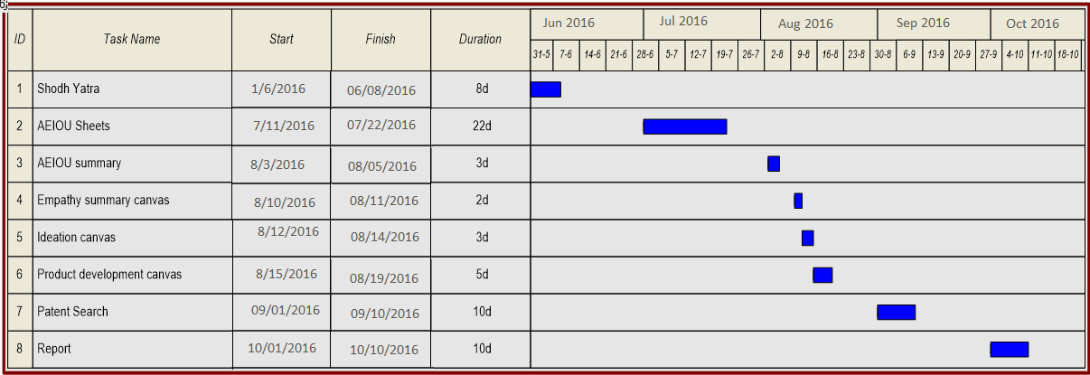

**Fig. 2.2.1 Shows timeline chart of this project**

**2.3 RISK MANAGEMENT**

Risk management consists of a series of steps that help a software development team to understood and manage uncertain problems that may arise during the course of software development and can plague a software project.

Risks are the dangerous conditions or potential problems for the system which may damage the system functionalities to very high level which would not be acceptable at any cost. so in order to make our system stable and give its 100% performance we must have identify those risks, analyse their occurrences and effects on our system and must prevent them to occur .

**2.3.1 Risk Identification**

Risk identification is a first systematic attempt to specify risks to project plan, scheduling resources, project development. It may be carried out as a team process using brainstorming approach.

**Technology risk:** Technical risks concern implementation, potential design, interfacing, testing, and maintenance problems.

➢ Database Corruptness

➢ Garbage Collection

**People Risks:** These risks are concerns with the team and its members who are taking part in developing the system.

➢ Leaking an important data

➢ Failure of the administration

➢ Lack of knowledge

➢ Lack of clear product vision.

➢ Technical staff conflict.

➢ Poor communication between people.

**Tools Risks:** These are more concerned with tools used to develop the system

➢ Tools containing virus.

**General Risks:** General Risks are the risks, which are concerned with the mentality and resources.

➢ Rapidly changing requirements.

➢ Lack of resources can cause great harm to efficiency and timely productivity.

➢ Changes in requirements can cause a great harm to implementation, designing and schedule of developing the system.

➢ Insufficient planning and task identification.

* Decision making conflicts.

**2.3.2 Risk Analysis**

**“Risk analysis = risk assessment + risk management + risk communication**. ”

Risk analysis is employed in its broadest sense to include:

**Risk assessment**

Involves identifying sources of potential harm, assessing the likelihood that harm will occur and the consequences if harm does occur.

For this project It might be:-System Crash.

**Risk management**

Evaluates which risks identified in the risk assessment process require management and selects and implements the plans or actions that are required to ensure that those risks are controlled.

Precautions taken to make risks minimal are as under:-

Periodical backups are taken to avoid major loss in case of system crash.

**Risk communication**

Involves an interactive dialogue between stakeholders and risk assessors and risk managers which actively informs the other processes.

Steps taken for risk communication is as under:-

* Probability of certain risks is negotiated with client.
* All the possible risks are listed out during communication and project is developed taking care of that risks.

**2.4 ESTIMATION**

In this semester we working till on Analysis Phase, we will do estimation part in next semester.

**CHAPTER-3 System Requirements Study**

**3.1 USER CHARACTERISTICS**

**Admin:-**

* Login
* Admin can add user and remove user.
* Admin can manage Database.
* Admin can manage Payment and visitors of user.
* Admin can manage Staff.
* Show user full detail

**User:-**

* Registration
* Login
* User can view comments and likes.
* Upload the new photos
* Like the photos
* Comment on photo
* Pay payment
* User settings and updating
* Take a tour of site.
* User can give ratting.
* User can chat with other user.

**3.2 HARDWARE AND SOFTWARE REQUIREMENT SPECIFICATION**

This shows minimum requirements to carry on to run this system efficiently.

**3.2.1 Hardware Requirements**

**Server side Hardware Requirement:**

|  |  |
| --- | --- |
| Devices | Description |
| Processor | Intel Core Duo 2.0 GHz or more |
| RAM | 2 GB or more |
| Hard Disk | 10 GB or more |

**Table 3.2.1.1 Server side Hardware Requirement**

**3.2.2 Software Requirements**

|  |  |
| --- | --- |
| **For which** | **Software** |
| Operating System | Windows XP/2003/vista/7/8/10,Linux,  Mac os x |
| Front End | HTML |
| Back End | MySQL Database |
| Scripting Language | JavaScript |
| Browser | Mozilla Firefox, Google Chrome, etc. |

**Table 3.2.2.1 Software Requirements**

* 1. **CONSTRAINTS**
     1. **Hardware Limitations**

The major hardware limitations faced by the system are as follows:

If the appropriate hardware is not there like processor, RAM, hard disks

* -the problem in processing requests of client
* -if appropriate storage is not there our whole database will crash due to less storage

because our main requirement is large storage.

* + 1. **Interfacing with other systems**

There should be the compatible browser to perfectly run our portal.

**3.3.3 Reliability Requirements**

Since many users can access the server simultaneously, load on the server becomes very high. Hence, the server should be of enough high configurations. There should be high back up storage and management of huge data for overall ideas, videos, images, multiple countries, and multiple user profile.

The Reliability requirements are the validations used to protect the system against one or more incorrect activities. Without proper validation of the system, the failure possibilities of it grow higher so it is must to understand the proper validation of the system and must implement them. All the required validator controls spend very good role to keep the system secure from any unauthorized or incorrect information.

In all these validation actions if system found one or more entries violating validation rules then user will be warned by proper error messages and the details or the record is not going to be saved until corrections are made to them.

* + 1. **Safety and Security Considerations**

**Safety:**

The Safety of the system is about organization part of concern as the system is going to be used in there but the solution for the safety of the system , the source of this website will be kept at more than one place with User Id , password and also in the developer's backup in case of system crash.

**Security:**

As a developer of the system we are responsible for providing the system a higher level of security as we all know that either it is a web application or any android application, system must be given a great level of security so that system will be used long last.

User's information will be kept confidential and hence security was a great part to concentrate for us. We have tried to secure the system from any unauthorized access by providing different users a different user id as per his or her designation. If user is Admin (Top Management), he/she will have all the access, privileges and constraints to use this system. He / She can access the entire database details. He/she is able to modify or delete any record or details from the database. Other users have limited access according to their designation in the organization. Because of limited privileges these other users will not be able to modify or delete other details or records of organization.

* 1. **ASSUMPTIONS AND DEPENDENCIES**

**Dependencies:**

The entire project depends on end-users operation. They should possess enough knowledge to work with the system.

**Assumptions**

* End-User is the person having enough knowledge for the project operation.
* The PC on which this software is used must meet its minimum requirements in

terms of hardware and software.

* Only Administrator person has all the privileges.
* The database is correct and up-to date every Time.
* The availability and reliability of the system is at the level what user wants in.
* The user of the system must beware about the various functionalities of the system and all

the operations of it.

Chapter-4 System Analysis

**4.1 STUDY OF CURRENT SYSTEM**

Current system allows the different persons to manage their society related work idea on website.

**4.2 PROBLEMS AND WEAKNESS OF CURRENT SYSTEM**

The current system is undoubtedly well-designed for crowd funding portal expenses but it has some following limitations:

* Lack of an awareness of this system.
* Available in Only city Area
* Some security related issues may be created.
* Idea stealing problem is there.

**4.3 REQUIREMENTS SPECIFICATION**

Requirements specification adds further information to the requirements definition.

**4.3.1 User Requirements**

Here two types of user can use this project

* **Admin:**

Admin users manage the entire project like login, management of

* Staff
* User
* Updation
* Event management
* Payment
* Maintenance cost
* **Users:**

These users can ….

* + Login
  + Register
  + Manage member details
  + Upload pictures
  + Like
  + Comment
  + Ask Questions

Etc.

* + 1. **System Requirements**
* **Usability:**

The interface should use terms and concepts, which are drawn from the experience of the people who will make most of the system. For example, basic social networking concepts are followed.

* **Efficiency**:

The system should provide easy and fast access.

**4.4 FEASIBILTIY STUDY**

An important outcome of the preliminary investigation is the determination that the system is feasible or not. The main aim of the feasibility study activity is to determine whether it would be financially and technically feasible to develop a project .The feasibility study activity involves the analysis of the problem and collection of all relevant information relating to the product such as the different data items which would be input to the system, the processing required to be carried out on these data, the output required to be produced by the system as well as the various constraints on the behaviour of the system.

**4.4.1. Does the system contribute to the overall objectives of the organization?**

The main aim of behind development of this system is to provide a web application that can provide online society management system.

**4.4.2. Can the system be implemented using the current technology and within the given cost and schedule constraints?**

* The system can be easily implemented using existing technology. The technology used is JAVA which is user friendly, secure and freeware. After seeing the functionality that system provides the cost of developing the application does not matter.
* Taking the schedule constraints in consideration the time available is approximately 9 months. The time period is enough to develop the system.

**4.4.3. Can the system be integrated with other system which is already in place?**

Yes, the system can be integrated with other system which is already in place. If other system wants to use our functionality it can be easily integrate.

**4.5 REQUIREMENT VALIDATION**

A requirements validation is concerned to check whether the requirements actually define the system, which the customer wants? Requirements validation is important because errors in requirements document can lead to extensive rework costs when they are subsequently discovered.

We have performed the following validation checks

* **Validity checks**

Check whether the information entered is in valid format.

* **Consistency checks**

A requirement in a document is not conflicting.

* **Completeness checks**

The requirements document includes requirement, which define all functions, and constraints intended by the system user.

* **Realism checks**

Using knowledge of existing technology, the requirements are checked to ensure that they could actually be implemented.

* **Verifiability**

The requirements are given in verifiable manner (e.g.: Using quantifiable measures) to reduce disputes between client and developer.

**4.6 FEATURES OF NEW SYSTEM**

We will try to develop application as follows:

* The system being available in regional languages.
* Provide the more awareness in our country about this concept.
* User can manage his/her society with the simplest or easy way.
* Communication provided between admin and society members.
* Safety for money transfer and surety of security of ideas.

**4.7 DATA FLOW DIAGRAM**

**Level-0:**

A data flow diagram (DFD) is a graphical representation of the "flow" of data through an information system.

In other words, it shows:

* What goes in
* How it is changed
* What comes out

A data flow diagram can also be used for the visualization of data processing (structured design). It is common practice for a designer to draw a context-level DFD first which shows the interaction between the system and outside entities. This context-level DFD is then "exploded" to show more detail of the system being modelled.

Data flow diagrams are a useful and initiative way of describing a system. They are normally understandable without special training. Especially if control information is excluded. They show end-to-end processing. That is the flow of processing from when data enters the system to where it leaves the system can be traced.

**Purpose**

To describe the functionality in (a part of) a system and the corresponding exchanges of data between the functions.

**Conventions used in drawing the Data Flow Diagrams are**



**DATA FLOW DIAGRAM (Level 0)**

**Level-0:**

A level 0 DFD, also called a fundamental system model or context diagram represents the entire software element as a single bubble with input and output data indicated by incoming and outgoing arrows, respectively.

**Request**

**Response**

Admin

Secretory

Visitor

User

**FIRST LEVEL DFD: Admin**

**Request**

**Response**

**Tbl_bill**

**Tbl_admin**

**Tbl_user**

**Tbl_user**

Admin

**Tbl_admin**

**FIRST LEVEL DFD: User**

**Request**

**Response**

User

**Tbl_member**

**Tbl_bill**

**Tbl_bill**

**Tbl_rating**

**Tbl_user**

**Tbl_cost**

**Tbl_Cost**

**Tbl_user**

**Tbl_admin**

**Tbl_user**

**FIRST LEVEL DFD: Secretory**

**Request**

**Response**

**Tbl_user**

**Tbl_user**

**Tbl_member**

**Tbl_secretory**

**Tbl_user**

Secretory

**Tbl_secretory**

**FIRST LEVEL DFD: Visitor**

**Request**

**Response**

Visitor

**Tbl_visitor**

**Tbl_member**

**Tbl_usre**

**Tbl_member**

**Tbl_user**

**4.8 ER DIAGRAM:**

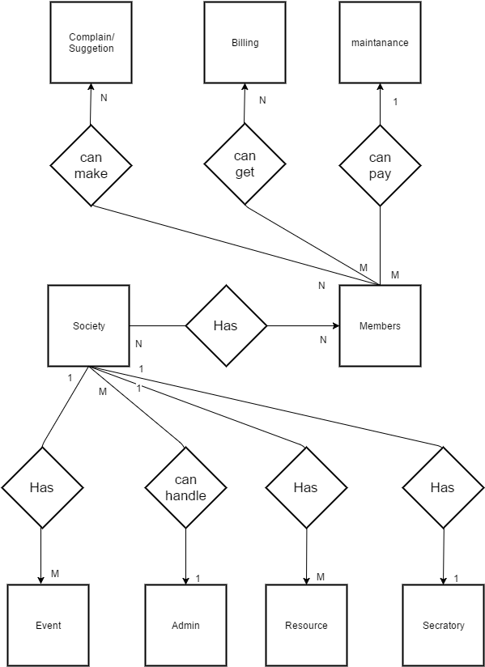

Chapter -5 System Design

**5.1 DATABASE DESIGN**

As a system data model is derived, many named entities, relationships and so forth will be identified. The names given to the entities should be chosen to give the reader some clues to their meaning. However, further description of the named entities is usually needed to make the model understandable. The description can be informal of the formal, whether which approach is used. It is always worth collecting all the descriptions in a single repository or data dictionary.

A data dictionary is simplistically a list of names used by the system, arranged alphabetically. As well as the name, the dictionary should include a description of the named entity and if the name represents a composite object, there may be a description of the composition. Other information such as the date of creation, the creator, and the representation of the entity may also be included depending on the type of the model which is being developed.

* **Advantages of using a data dictionary are:**

It is a mechanism for name management. Many different people who have to invent names for entities and relationships may develop a large system model. These names should be used consistently and should not clash with their meanings. The data dictionary software can check for the name uniqueness and tell requirements analyst of the name duplications.

It serves as a store of organizational information which can link analysis, design, implementation and evolution. As the system is developed, information is taken to inform the development. New information is added to it. All information about an entity is in one place.

All system names, whether they are names of entities, types, relations, attributes or services should be entered in the dictionary. Support software should be available to create, maintain and interrogate the dictionary. This software might be integrated with other tools so that dictionary creation is partially automated

**Database Tables:**

Account history:

1. Tbl_admin

|  |  |  |
| --- | --- | --- |
| **Fields** | **Data Type** | **Constraints** |
| admin_id | Int | P.K |
| admin_nm | Varchar(30) |  |
| admin_email | Varchar(100) |  |
| admin_psw | Varchar(20) |  |
| admin_con_no | Varchar(15) |  |

1. Tbl_secretory

|  |  |  |
| --- | --- | --- |
| **Fields** | **Data Type** | **Constraints** |
| secretory_id | Int | P.K |
| secretory_f_nm | Varchar(30) |  |
| secretory_l_nm | Varchar(30) |  |
| secretory_profie | Varchar(max) |  |
| secretory_email | Varchar(100) |  |
| secretory_psw | Varchar(15) |  |
| secretory_photo | Varchar(max) |  |
| secretory_status | Bit |  |
| secretory_con_no | Varchar(15) |  |
|  |  |  |

1. Tbl_user

|  |  |  |
| --- | --- | --- |
| **Fields** | **Data Type** | **Constraints** |
| user_id | Int | P.K |
| user_f_nm | Varchar(30) |  |
| user_l_nm | Varchar(30) |  |
| user_email | Varchar(100) |  |
| user_psw | Varchar(15) |  |
| user_photo | Varchar(max) |  |
| user_status | Bit |  |
| User_con_no | Varchar(15) |  |

1. Tbl_member

|  |  |  |
| --- | --- | --- |
| **Fields** | **Data Type** | **Constraints** |
| member_id | Int | P.K |
| member_f_nm | Varchar(30) |  |
| member_l_nm | Varchar(30) |  |
| member_profie | Varchar(max) |  |
| member_email | Varchar(100) |  |
| member_psw | Varchar(15) |  |
| member_photo | Varchar(max) |  |
| member_status | Bit |  |
| member_con_no | Varchar(15) |  |

1. Tbl_Bill

|  |  |  |
| --- | --- | --- |
| **Fields** | **Data Type** | **Constraints** |
| bill_id | Int | P.K |
| bill_name | Varchar(30) |  |
| bill_date | Varchar(100) |  |
| User_id | Varchar(20) | F.K |
| bill_status | Varchar(20) |  |

1. Tbl_maintanance

|  |  |  |
| --- | --- | --- |
| **Fields** | **Data Type** | **Constraints** |
| maintanance_id | Int | P.K |
| maintanance_name | Varchar(30) |  |
| maintanance_cost | Varchar(100) |  |
| maintanace_status | Varchar(20) |  |

1. Tbl_Event

|  |  |  |
| --- | --- | --- |
| **Fields** | **Data Type** | **Constraints** |
| Event_id | Int | P.K |
| Event_type | Varchar(30) |  |
| Event_Bill | Varchar(100) |  |
| Event_Status | Varchar(20) |  |
| Member_id | Varchar(20) | F.K |
| User_id | Varchar(20) | F.K |

1. Tbl_Complaint

|  |  |  |
| --- | --- | --- |
| **Fields** | **Data Type** | **Constraints** |
| Complaint_id | Int | P.K |
| Complaint_subject | Varchar(30) |  |
| user_id | Varchar(10) | F.K |
| Complaint_status | Varchar(10) |  |
| Member_id | Varchar(10) | F.K |

1. Tbl_Society

|  |  |  |
| --- | --- | --- |
| **Fields** | **Data Type** | **Constraints** |
| society_name | Int | P.K |
| society_wing | Varchar(30) |  |
| user_id | Varchar(100) | F.K |
|  |  |  |

**5.2 INPUT / OUTPUT DESIGN**

**Sign in page:**

Where user can perform sign in operation.

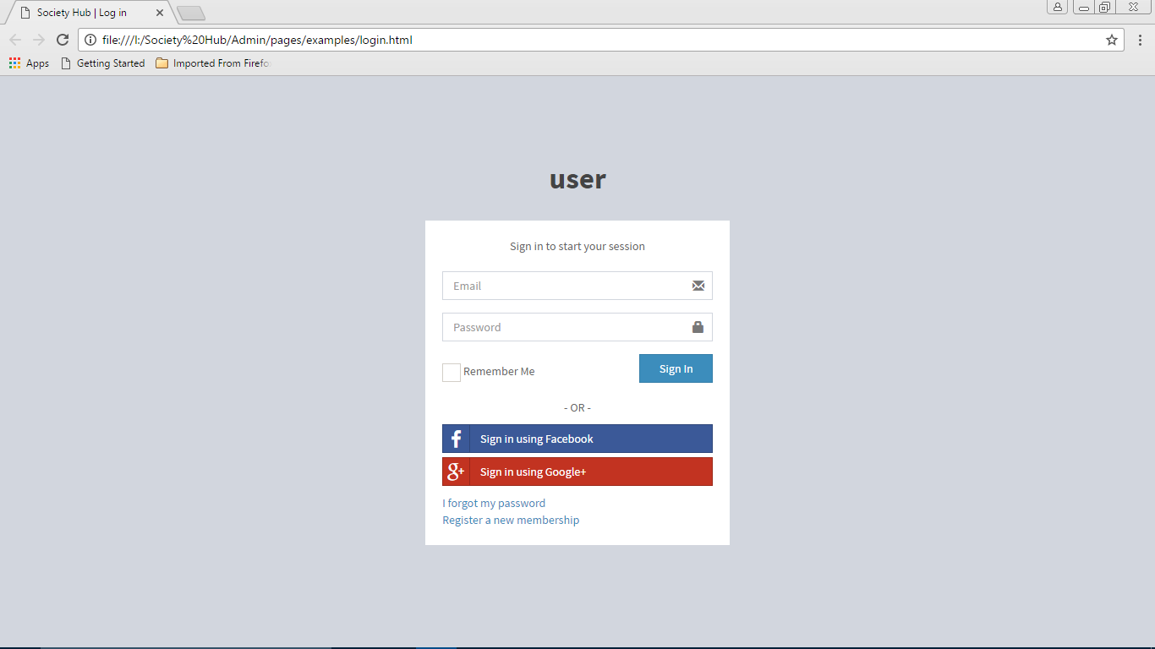

**5.3 INTERFACE DESIGN**

**5.3.1 State-Transition Diagram**

➢ State diagrams show the dynamic behaviour of a system. The diagram shows

the various states that an object can get into and the transitions that occur

between the states.

**Graphical Notation**

* **State**:

The state object is a snapshot of an object at a particular point in its life. A state may have an activity describing the function being performed.

* **Initial State:**

The initial state is the starting state of the object with reference to the

behaviour that the diagram explains. Each state diagram should have only

one initial state.

* **Final State:**

Each final state is the ending state of the object with reference to the

behaviour that the diagram explains. There may be multiple final states for an object.

* **Transition:**

The transition link represents the relationship between different states of an Object. The transition guard is a condition which limits the cases in which a transition can occur. The transition action is performed during the transition and cannot be interrupted

Appendix

A.1 Summary

Managing projects in effective ways is important for all IT Companies and Other Industries and is also the main focus of a number of academic initiatives. The Project Canvas is a convenient tool for communicating within the project team and fellows related with academic purpose, for decision making, and is thereby also a way of managing progress in the appropriate manner. Therefore, the success of a project is closely linked to the team’s ability to plan, adjust and react to changing circumstances. Project Canvas is created in order to help all members of a team obtain a clear overview of a project.

Project Canvas Schedule:

Announcement related to CANVAS

Observation & AEIOU SHEETS MAKING

AEIOU SUMMARY SHEET

EMPATHY SUMMARY CANVAS

IDEATION CANVAS MAKING

PRODUCT DEVELOPMENT CANVAS

EXHIBITION OF CANVASES

**A.2 AEIOU SUMMARY CANVAS:**

**ACTIVITIES:** list the activities which user can perform.

**ENVIRONMENT:**

Which affects the users?

**OBJECTS:**

What components are involved and how?

**INTERACTION:**

Who is interacting, with whom and what?

**USERS:**

Who is present? Roles and responsibilities.

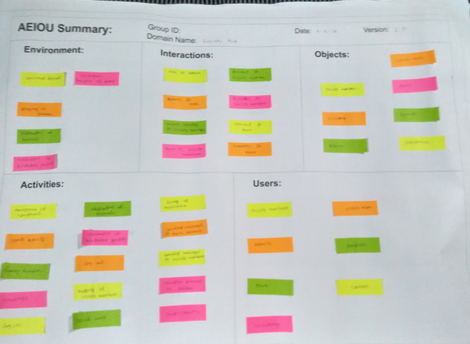

**Fig.A.2.1 AEIOU SUMMARY**

**A.3 EMPATHY SUMMARY CANVAS:**

When defining the empathy summary canvas, the team explores the problem with prior technologies, selection of the some feasible problem and procedure to overcome the problem. The elements should be revised until a satisfactory scope has been created.

To make the best use of Project Canvas, all members related with project should commonly agree upon and authorize the defined problem and steps to overcome that problems before initiating the project.

All these activities and their summary were jotted down by all the students in their canvas using sticky notes. They had funnelled out a single scope and limitation that will be overcome by their projects.

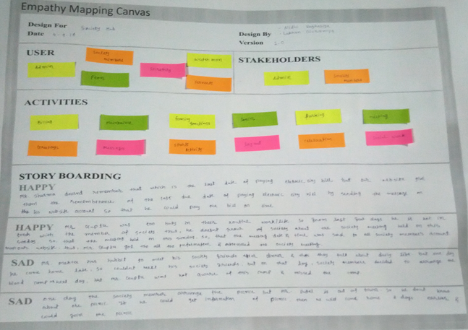

**Fig.A.3.1 EMPATHY SUMMARY**

**A.4 IDEATION CNAVAS:**

1. **People :**

Stack holders or the User who can use our project. These are the stakeholders who can

make decision related to the Project.

1. **Activities :**

Activities are the process that are performed by the People related to the Project.

1. **Situation :**

The above mentioned activities will be performed by the people on particular situation,

for some reason, on some specific location.

**(4) Possible Solution:**

Possible solution are the effort that are done to implement the activities performed by the

People.

All these points were covered in this canvas it focused on the people being influenced by the project, Activities to be done to achieve the mile stones.

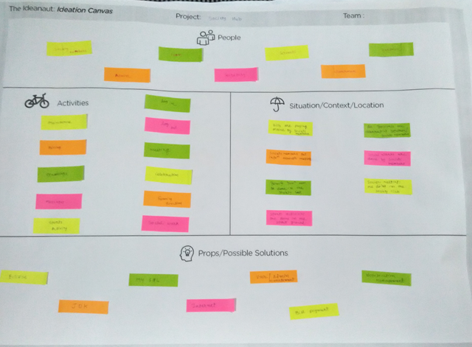

**Fig.A.4.1 IDEATION CANVAS**

**A.5 PRODUCT DEVELOPEMENT CANVAS:**

Third task was to create **“Product Development Canvas”.**This canvas is about the solution to be developed. What is the purpose? Who is the user? What are the features? What are the functions? What are the components? These all things are to be pointed out in this canvas.

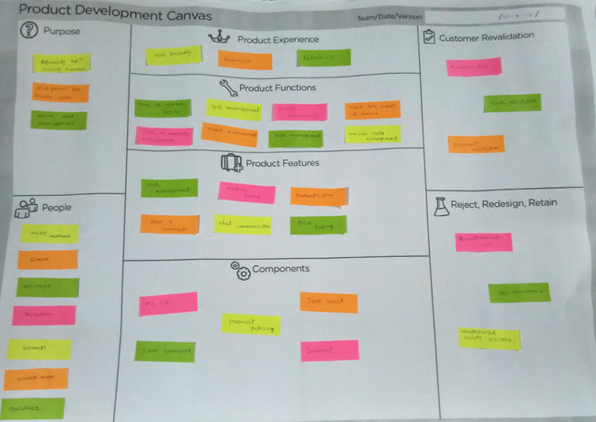

**Fig.A.5.1 PRODUCT DEVELOPMENT CANVAS**

**A.6 EXHIBITION OF CANVAS:**

An exhibition of these canvas made by all the teams was carried out at the Computer Department of Atmiya Institute of Technology and Science.

Event started at 02.00 pm on 24st of September. All the teams gave presentation on their respective canvas.

Our respected Principle DR. G. D. Acharya along with our H.O.D Ma’am Ms. Trupti Kodinariya and Professor Ms.Nirali Varnagar inspected these canvases and gave valuable advices on our project. A healthy participation from the students gave their opinion toward the enrichment of the project canvas.

Based on advices and suggestion we have reflected changes relatively.

**References**

* + [**WWW.GOOGLE.COM**](http://WWW.GOOGLE.COM)
  + [**WWW.W3CSCHOOL.COM**](http://WWW.W3CSCHOOL.COM)
  + [**WWW.MONSTER.COM**](http://WWW.MONSTER.COM)
  + [**WWW.STACKOVERFLOW.COM**](http://WWW.STACKOVERFLOW.COM)
  + **WWW.GETBOOTSTRAP.COM**